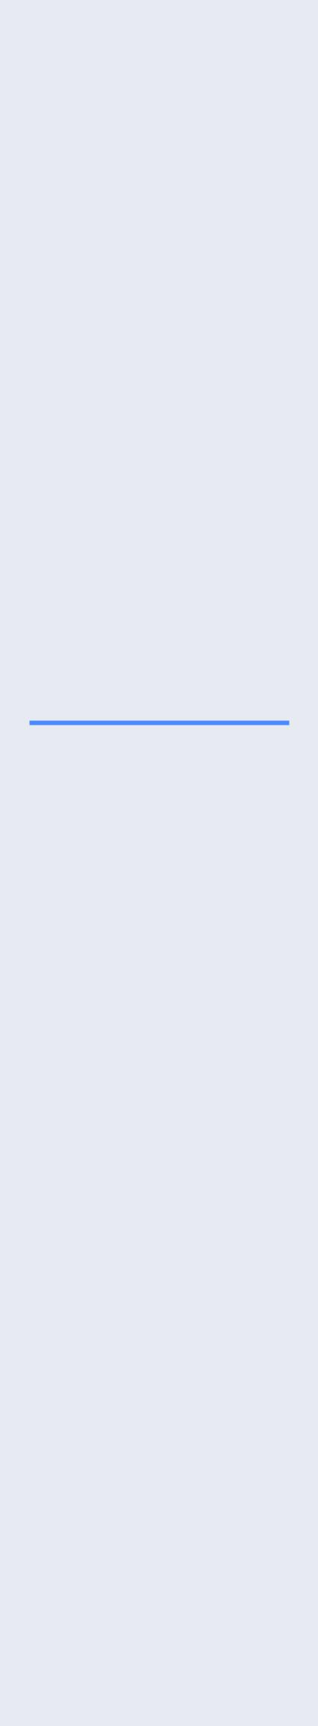
OJAS

MADAN

ojasmadan@hotmail.com +919952041233
201, Aradhana Apartments

R.K.Puram New Delhi110066

- Bachelor of Technology from VIT with a Cumulative GPA of 8.13
- Team player with administrative skills.

Skills

PROGRAMMING LANGUAGES:

C

C++

JAVA
XML

WEB TECHNOLOGIES:

HTML

OPERATING SYSTEM:

Windows Enviorment

Linux Enviorment

DATABSE:

MYSQL

Vitae
- Date of Birth: 2nd June 1996

- Languages: Well versed in English, Hindi and Basic French.

- Hobbies: Swimming, Table-Tennis, Photoshop and Drawing.

Objective

To obtain an internship within my chosen field that will challenge me and allow me to use my education, skills and past experiences in a way that is mutually beneficial to both myself and my employer and allow for future growth and advancement.

Education
VIT University

• B-Tech, third year in Computer Science Engineering, 2016-2017.

Ryan International

• XII from CBSE (Central Board of Secondary Education) Board, 2014.

Ryan International

• X from CBSE (Central Board of Secondary Education) Board, 2012.

Certifications

- Certification in Android Programming at NIIT, 2016.

- Certification in Core Java at NIIT, 2016.

- Certification in CISCO Networking at VIT, 2015.

- Certification in Windows Mobile Application Development at VIT, 2014.
- Certification in Cloud Computing at VIT, 2014.

Projects
Educational Learning Android Application
Designing an Educational learning application for kids (age group 4-7).The coding
Will be done in JAVA and XML.The application will be completed around
Mid-November. The application includes alphabets, numbers, colours, rhymes
Etc. and it teaches kids in a user-friendly way.
Current

Tic Tac Toe game using C++ | Oct 2013 to Nov 2013
Bank Management System using C++ | Jul 2014 to Sep 2014
Awards
Microsoft mobile application development hackathon | 2014

Won 2nd Price in Microsoft mobile application development Hackathon

Extra-Curricular Activities
- Participated in Dance club event “Curtain Raiser’16”.

- Participated in Drawing competition at Riviera’16 (VIT Vellore cultural festival), 2016.

- Participated in Flash mob at Vibrance’16(VIT Chennai cultural fest), 2016.
- Participated in informal and formal events at Technovit’15(VIT Chennai Tech. fest), 2016.

